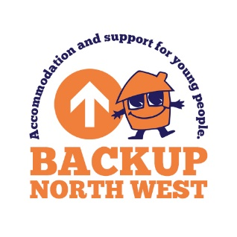

The Van: Booking Form

Thank you for your interest in booking ‘The Van’

The Van is a social enterprise, set up on behalf on BACKUP North West, a charity established to support homeless young people. By booking the Van for your event, you are contributing vital funds which will go back into the services provided for the young people at BACKUP. In addition, The Van encourages BACKUP residents to volunteer; helping them to gain work experience and learn new skills.

Contact Details

Contact Name
Company Name
Address
Postcode
Contact telephone number
Facebook
Instagram
Twitter

Event Details

Contact Name
Location
Address
 | Postcode
Contact telephone number
Emergency contact number for the Event
Description of Event
Date of the Event
Event Timings | Start: |  |  |  |  |  | Finish:
Times you wish The Van to be available for guests
 | Start: |  |  |  |  |  | Finish:
Expected number of guests
Are guests expected to pay for their own drinks and cakes ? |  |  |  |  |  |  |  |  | Yes | ☐ |  | No | ☐

If ‘No’, please state what you want The Van to provide:
 | Item | Numbers
 | Hot drinks
 | Cakes
 | Other (please state what this is)

Description of Pitch (location, indoor, outdoor, grass, hard standing, approx. size, etc.)

Is there access to toilet facilities for staff working on The Van ?
 | Yes | ☐ | No | ☐

Is fresh water available ? | Yes | ☐ | No | ☐

Is electricity available (16 AMP) ? | Yes | ☐ | No | ☐

If not, we can bring our own generator, however this can be noisy so we will need to check with you that this will not disturb your guests or the event as a whole.

Further information / requests:

Signed on behalf of the hirer:

Name
Signature
Date

Please scan and return by email to thevan@backup-charity.org.uk

